SPONSORSHIP PACKET

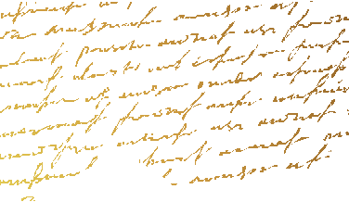
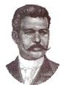
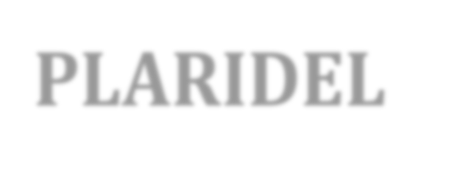
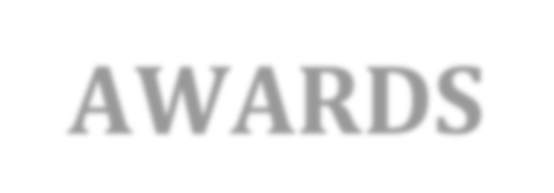
PH I L I PPI N E AM E R I CAN PR E S S CL U B, US A

EXCELLENCE IN FILIPINIO AMERICAN JOURNALISM

The 2019 Plaridel Awards Ceremony Thursday, October 3, 2019; 6:30 PM San Francisco Filipino Cultural Center
814 Mission Street,
San Francisco, CA
HERO / BAYANI $10,000 Founding Sponsor
- Logo placement on event website
- Full page ad in souvenir program with Awardee Proﬁle
- Live acknowledgment by hosts –
- PREMIUM Logo placement on registration wall during reception
- 10 VIP tickets to the reception
- Opportunity to present a Plaridel Award Category

FREEDOM / MALAYA $5,000
- Full page ad in souvenir program – with Awardee Proﬁle.
- Logo placement on event website.
- Live acknowledgment by hosts –
- Logo placement on registration wall during reception
- 6 VIP tickets to the reception
- Opportunity to present a Plaridel Award Category

HONORABLE / MAGITING $2,500
- Full Page ad in souvenir program.
- Company name included in the list of acknowledgments on the website
- Logo placement on registration wall during reception
- 4 VIP tickets to the reception
- Opportunity to present a Plaridel Award Category

STEADFAST / MASIPAG $1,000
- Company name included in the list of acknowledgments on the website.
- Half - page ad in souvenir program
- 4 VIP tickets to the reception
- Opportunity to present a Plaridel Award Category

FRIEND / KAIBIGAN $500
- Company name included in the list of acknowledgments on the website and inside souvenir program
- Half-page ad in souvenir program
- 2 tickets to the reception
---------------------------------------------------------------------------------------------------
ADVERTISING OPPORTUNITIES
HALF PAGE – with two (2) $ 400
QUARTER PAGE – with one ticket $250
SPECIAL DONOR – Line Acknowledgement & 1 Ticket $100

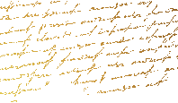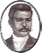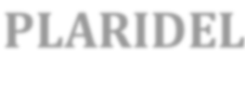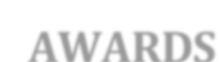
PLARIDEL
AWARDS

We are proud to be a part of the Philippine American Press Club’s PLARIDELAWARDS
- Excellence in Filipino American journalism - now on its 8th year.

COMPANY / ORGANIZATION: REPRESENTATIVE NAME:
JOB TITLE: ADDRESS:
CITY / STATE / ZIP: WEBSITE: TELEPHONE: MOBILE:
EMAIL:

SELECT SPONSORSHIP LEVEL:
;EXCELLENCE IN FILIPINO AMERICAN JOURNALISM

_____ Hero/Bayani $10,000
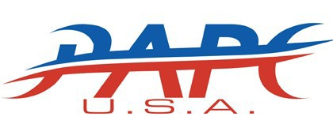

_____ Freedom/Malaya $ 5,000
_____ Honorable/Magiting $ 2,500
_____ Steadfast/Masipag $ 1,000
_____ Friend/Kaibigan $ 500

ADVERTISING OPPORTUNITIES: HALF PAGE: $500 QUARTER PAGE: $350 DONOR: $150

SOUVENIR PROGRAM MECHANICAL REQUIREMENTS: (PDF, JPEG, TIFF ﬁle formats are accepted)
Full Page Ad:  Half Page Vertical: | 7.5” x 10”  3.66” x 10” | Half Page Horizontal:  Quarter Page: | 7.5” x 4.86”  3.66” x 4.86”
Print-ready Artwork Deadline: Sept. 25, 2018

TERMS AND CONDITIONS:

Please make checks payable to PHILIPPINE AMERICAN PRESS CLUB, and mail it to
1799 Old Bayshore Hwy., Ste. 136, Burlingame, CA 94010

SIGNATURE DATE

PRINT NAME TITLE

For more information: Please contact plaridelpapc@gmail.com

