THE 6TH PLARIDEL AWARDS ENTRY FORM

Submissions open June 1, 2017

Entries must have been published or aired
between June 1, 2016 to May 31, 2017
Deadline for submissions is July 31, 2017

Awards ceremony will be on Friday, October 6, 2017 at 6:45PM at the Kalayaan Hall of the Philippine Center on 445 Sutter Street, San Francisco.

Each and every submission needs to be accompanied by an Entry Form and $15 fee.
For Multiple entries from one journalist – one set of photo and resume will suffice.
PLEASE email Photo to esther.chavez@inquirerinc.net.
Visit www.papcusa.org for more information.

Contacts:
Jojo.peralta@asianjournalinc.com or
Esther.chavez@inquirerinc.net

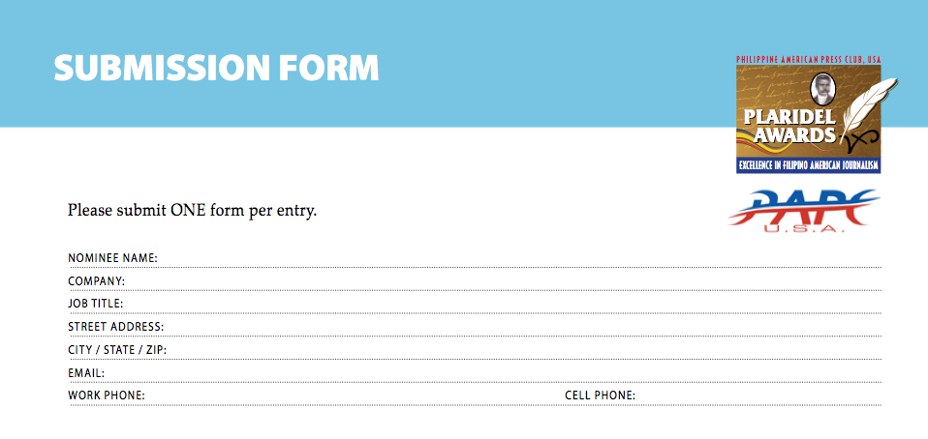
Note: Only two (2) entries/articles per Category, and no more than (3) Categories per journalist.

ENTRY INFORMATION
Award category (select one):
PRINT/ONLINE
☐ Plaridel 1 Investigative/In-depth Story
☐ Plaridel 2 Commentary/Editorial Essay
☐ Plaridel 3 News Story
☐ Plaridel 4 Feature Story
☐ Plaridel 5 International Reporting
☐ Plaridel 6 Entertainment Story
☐ Plaridel 7 Sports Story
☐ Plaridel 8 Food Story
☐ Plaridel 9 Youth Voice

Plaridel 10 Profile Writing
Plaridel 11 Personal Essay
Broadcast Category - Television
☐ Plaridel 12 Community Reporting
☐ Plaridel 13 Personality Profile

Broadcast Category - Radio
☐ Plaridel 14 The Ness Ocampo Memorial
Radio Award
☐ Plaridel 15 Photo Journalism
☐ Plaridel 16 Tourism Feature Story

Title of Article/Program/Subject: _______________________________________________________
Media outlet where submission appeared: _________________________________
Address of Media Outlet: ________________________________________________
Business phone and Email of Media Outlet: __________________________________________
Date(s) on which entry appeared or was aired:________________
Confirmed by (Print name): ____________________________________________
Job Title (Publisher / Editor / Producer / etc.): ______________________________
Signature:________________________________

ENCLOSE: $15 ENTRY FEE
MAIL TO: PHILIPPINE AMERICAN PRESS CLUB - 355 GELLERT BLVD., STE. 255DALY CITY, CA 94015

